A000-Afr-Congo DR-Headrest-Double Caryatid--Wood-19th c

***Note:******The Democratic Republic of the Congo*** *has been known as, in chronological order, the Congo Free State, Belgian Congo, the Republic of Congo-Léopoldville, the Democratic Republic of the Congo and the Republic of Zaire, before returning to its current name the Democratic Republic of the Congo or, hereinafter, Congo DR.*

***Note: The Kongo people*** *(singular: Mukongo, pl. Bakongo) speak Kikongo, a Bantu language, who have lived along the Atlantic coast of Central Africa, in a region that, by the 15th century, was a centralized and well-organized Kongo Kingdom but is now a part of three countries: the Democratic Republic of the Congo, the Republic of the Congo and Angola.*

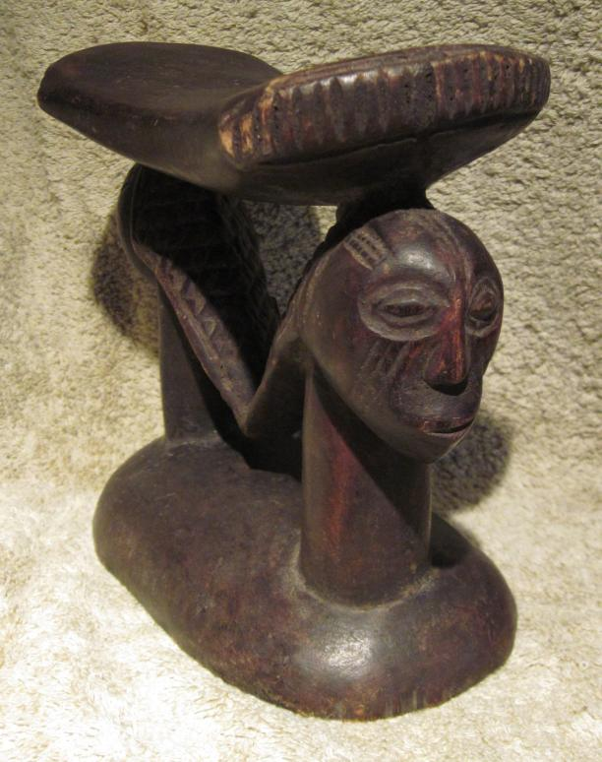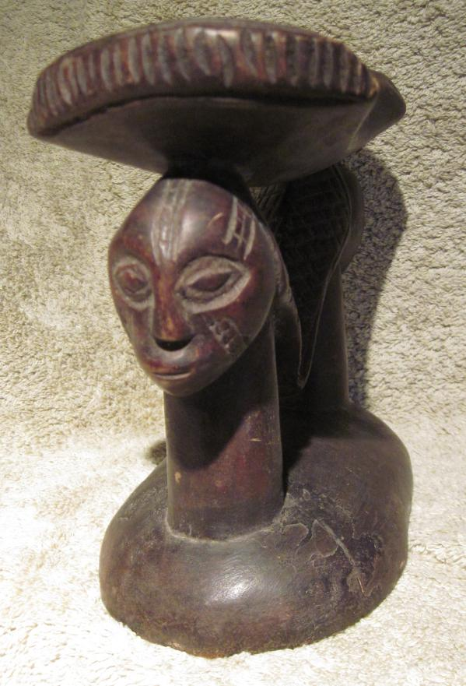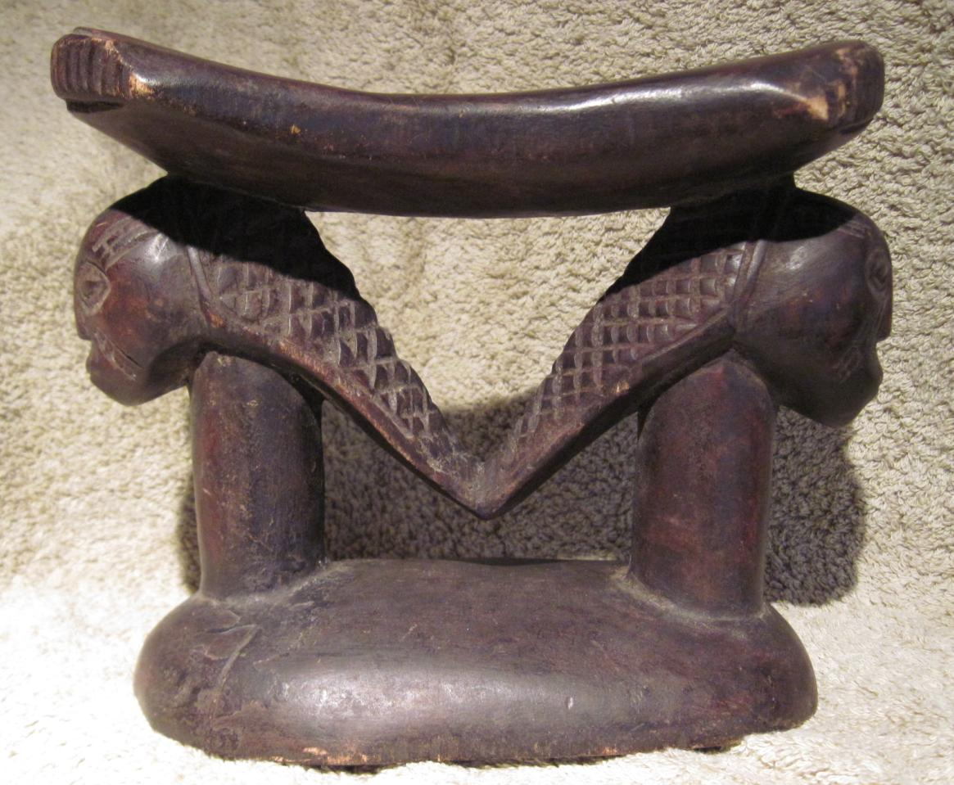

**Case no.: 6**

**Accession Number:**

**Formal Label:**

**Display Description:**

**LC Classification: N1099.C6**

**Date or Time Horizon:**

**Geographical Area:**

**Map:**

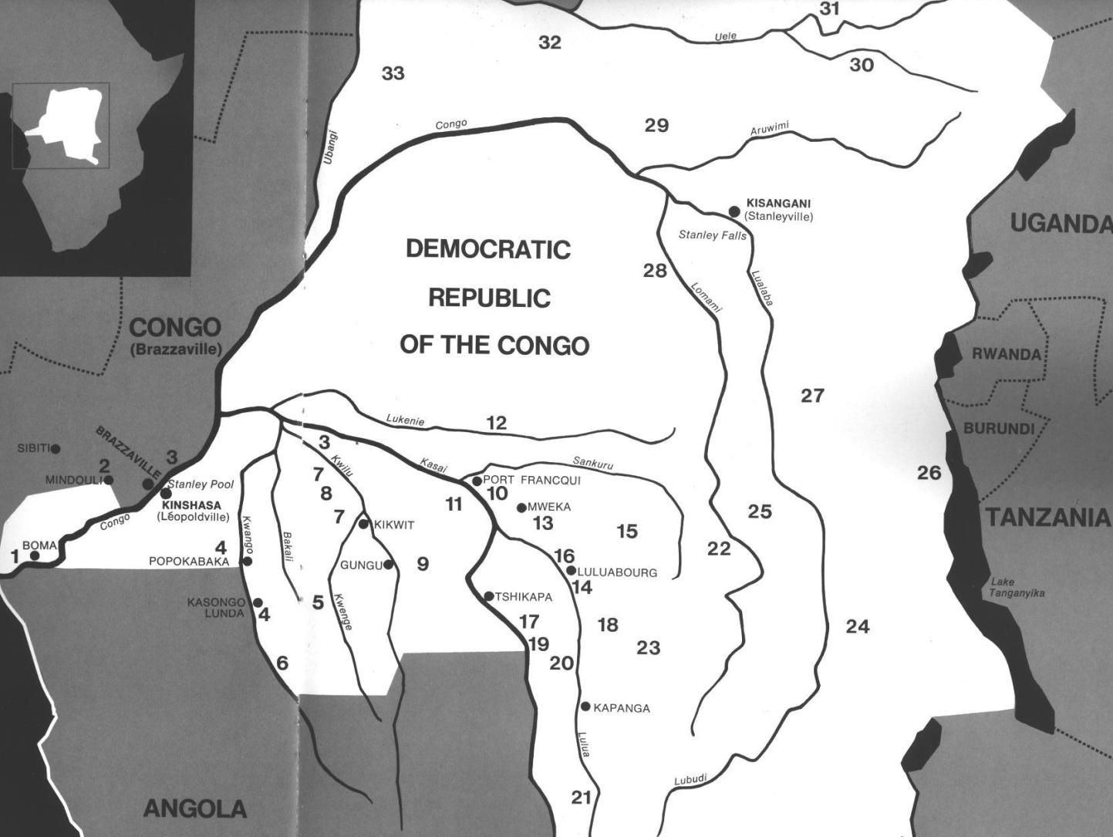

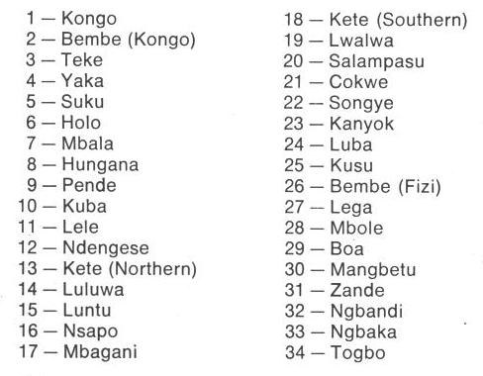

Fig. 1. Map of Kongo Cultures, West Central Africa. After Walker Art Center 1967. 9 is Pende.

**GPS coordinates:** 7° 46' 19.3" (7.772°) S, 24° 17' 44.9" (24.2958°) E

**Cultural Affiliation:** Pende, Central Bantu

**Media:** wood, raffia, kaolin, ferruginous earth

**Dimensions:** H 20.866 in

**Weight:** 2.52 pounds

**Condition: original**

**Provenance:** Kitangwa

**Discussion:**

**References:**

Adams, Monni. 1988. 8th century Kuba king figures, *African Art* 21(3): 32-38, 88.

Belepe, Bope. 1974. *Etude socio-morphologique des masques Bwoom des Kuba: Memoire de licence en histoire.* Lubumbashi: Université Nationale du Zaire.

Belepe, Bope. 1981. Les oeuvres plastiques Africaines comme documents d'histoire: Le cas des statues Royales Ndop des Kuba du Zaire, *Africa­Tervuren* 25(1): 9-17.

Binkley, D. 1987. Avatar of power: Southern Kuba masquerade figures in funerary context, *Africa* 57 (1).

Binkley, D. 1990. Masks, space and gender in southern Kuba initiation ritual, *Iowa Studies in Art.* Vol. 3, *Art and Initiation in Zaire.* Iowa City: The University of Iowa.

Brett-Smith, Sarah. 1983. “The Doyle Collection of African Art,” *Record of the Art Museum, Princeton University*, 42(2): 2+8-34.

Kuba du Zaire, Africa­ Tervuren 27(1): 9-17.

Binkley, D. 1987. Avatar of power: Southern Kuba masquerade figures in funerary context, *Africa* 57 (1).

Binkley, D. 1990. Masks, space and gender in southern Kuba initiation ritual, *Iowa Studies in Art.* Vol. 3, *Art and Initiation in Zaire.* Iowa City: The University of Iowa.

Claerhout, A. 1976. Two Kuba wrought-iron statuettes, *African Art* IX (4): 60-64.

Cornet, J. 1972. *Art de l'Afrique Noire au pays du fleuve Zaire*. Brussels: Arcade.

Cornet, J. 1975. *Art from Zaire: 100 Masterworks from the National Collection.* New York: African-American Institute.

Cornet, J. 1982. *Art royal Kuba.* Milan: Sipiel.

Ehret, Christopher. 2002. *The civilizations of Africa: a history to 1800*. Charlottesville: Virginia: University of Virginia Press.

Forbath, Peter. 1977. *The River Congo*. Boston: Houghton Mifflin.

Laman, Karl. 1953. *The Kongo*. 4. vols. Stockholm: Victor Pettersons.

MacGaffey, Wyatt. 1986. *Religion and society in central Africa: the Bakongo of Lower Zaire*. Chicago: University of Chicago Press.

MacGaffey, Wyatt. 1988. “Complexity, astonishment and power: the visual vocabulary of Kongo minkisi,” *Journal of African Studies*, (14:2), 188-203.

Martinez-Ruiz, Barbaro. 2013. *Kongo Graphic Writing and other Narratives of the Sign*. Philadelphia: Temple University Press.

Rosenwald, J. B. 1974. “Kuba king figure,” *African Art,* VII (3).

Schadeberg, Thilo. 1999. “Batwa: the Bantu name for the invisible people.” In *Challenging Elusiveness: Central-African Hunter Gatherers in a Multidisciplinary perspective*, ed. K. Beibrouck, S. Elders, and G. Rossel. Leiden: CNWS, 21-39.

Thompson, Robert Farris. 1978. “The Grand Detroit N’kondi,” *Bulletin of the Detroit Institute of Arts* 56 :4, 206-217.

Torday, E. and T. A. Joyce. 1911. « Notes ethno­graphiques sur les peuples communement appeles Bakuba, ainsi que sur les peuplades apparentees, les Bushoongo. » In *Annales du Musee Royal du Congo Belge, Ethnographie et Anthropologic.,* serie III, tome II, fasc. 1. Brussels: Tervuren.

Vansina, Jan. 1955 “Initiation Rituals of the Bushong,” *Africa* 25(2): 138-153.

Vansina, Jan. 1964. *Le royaume kuba.* Tervuren: Musée royal de l'Afrique centrale.

Vansina, Jan. 1978. *The children of Woot. A history of the Kuba peoples.* Madison: University of Wisconsin Press/Dawson.

Vansina, Jan. 1984. *Art History in Africa.* London: Longman.

Van Wing, Joseph Hubert Leopold. 1941. *Études Bakongo*. II. *Religion et magie*. Institut royal colonial belge. Section des sciences morales et politiques. Mémoires, collection in-8°, t. IX, fasc. 1. Brussels: Desclée de Brouwer.

Van Wing, Joseph Hubert Leopold. 1959. *Études Bakongo.* Brussels: Desclée de Brouwer.

Walker Art Center. 1967. *Art of the Congo*. Minneapolis: Walker Art Center.